
ROBOT EMBEDDED PROGRAMMING
Lab 2: Software Installation - Linux, ROS 2, and Python

FACULTY OF APPLIED SCIENCES AND TECHNOLOGY

Name:
Lance Quan
Michael McCorkell
Percy Sanford
Tyler Brannon

Objective
Guide students through setting up their development environment:
1. Enable WSL 2 on Windows 11.
2. Install Ubuntu 24.04 from the Microsoft Store.
3. Install ROS 2 Jazzy using the official Debian package method.
4. Confirm Python installation and optionally set up Visual Studio Code.

Step 1: Enable WSL 2
1. Open 'Turn Windows features on or off'.
2. Tick the checkboxes for:
- Virtual Machine Platform
- Windows Subsystem for Linux
3. Click 'OK' and restart your computer.
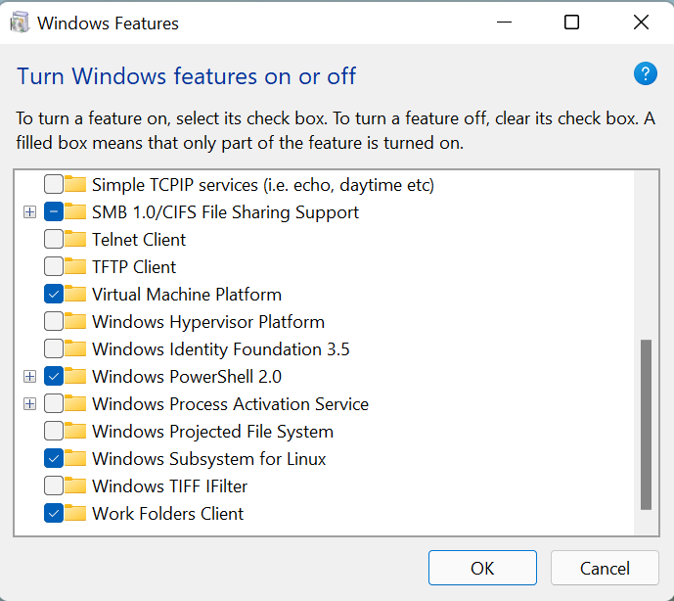
4. After restart, open Command Prompt and check WSL version:
wsl –status
Note: Make sure to be on root directory C:\
5. If WSL is not installed, just install it by typing the following command:
wsl.exe –install
6. You will be prompted to create a Linux username and password.
- Choose a simple username (all lowercase, no spaces).
- Enter a password.
- IMPORTANT: Do not forget your password.
7. After done installing it, close the CMD window.
8. Open a new CMD and type: wsl --status
9. If prompted to update, run:
wsl --update
10. Wait for the update to complete before continuing.

Step 2: Install Ubuntu 24.04 via Microsoft Store
- Install Ubuntu 24.04 by typing the following in the CMD:
wsl --install -d Ubuntu-24.04
2. Close CMD and search for Ubuntu-24.04 in your windows search bar.
3. Launch it for the first time. You will be prompted to create a Linux username and password.
- Choose a simple username (all lowercase, no spaces).
- Enter a password.
- IMPORTANT: Do not forget your password.
4. Confirm installation with:
lsb_release -a
Example of first-time Ubuntu launch and user creation:
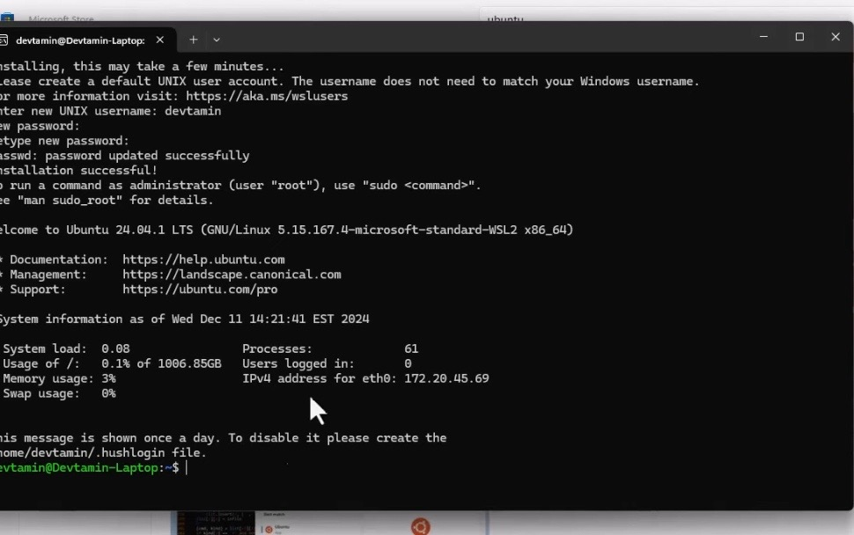

Step 3: Install ROS 2 Jazzy
During the lab, follow the official ROS 2 Jazzy Ubuntu installation guide directly from the ROS documentation site:
https://docs.ros.org/en/jazzy/Installation/Ubuntu-Install-Debs.html
NOTE: IGNORE the code for “ROS-Base Install (Bare Bones): Communication libraries, message packages, command line tools. No GUI tools.”
This ensures you are using the most up-to-date instructions.
The main steps include:
- Setting your system locale to UTF-8
- Enabling necessary repositories
- Adding the ROS 2 apt source
- Installing ROS 2 Jazzy packages (desktop or base)
- Setting up your environment so ROS 2 loads automatically
- Testing the installation using example talker/listener nodes

Step 4: Install Visual Studio Code
- Install Visual Studio Code via Microsoft Store or the official website.
- Open the Microsoft Store and search for “Visual Studio Code.”
- Click on the “VS Code” entry in the search results.
- Click the “Get” button to download and install VS Code.
- Once the installation is complete, click the “Launch” button to open VS Code.
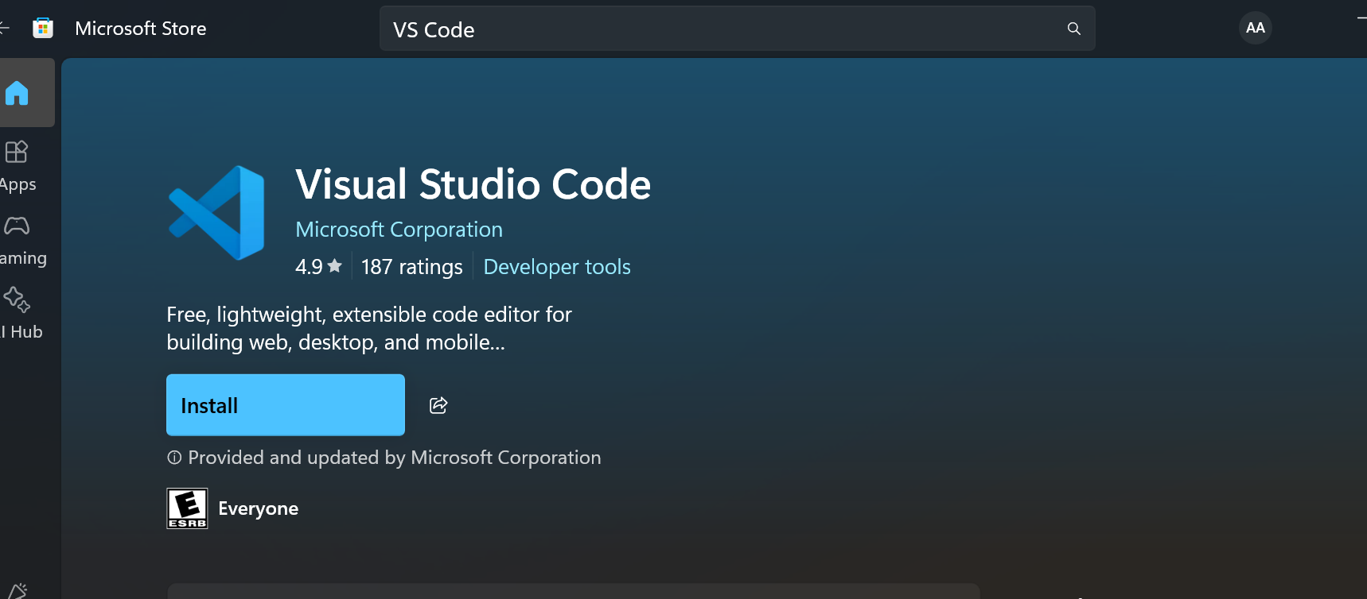

- Install VS Code on WSL2 (Ubuntu 24.04)
- Launch your Ubuntu 24.04 terminal and run the following command:

- This will ask you to install the x64 Visual Studio Code server. Agree with yes or by pressing Enter. After this, you can launch VS Code right out of your WSL2 terminal by typing: code
- You can open any folder inside of WSL 2 directly with VS Code by navigating to the folder you want to open and then just typing: code .
- Click Yes to trust the author
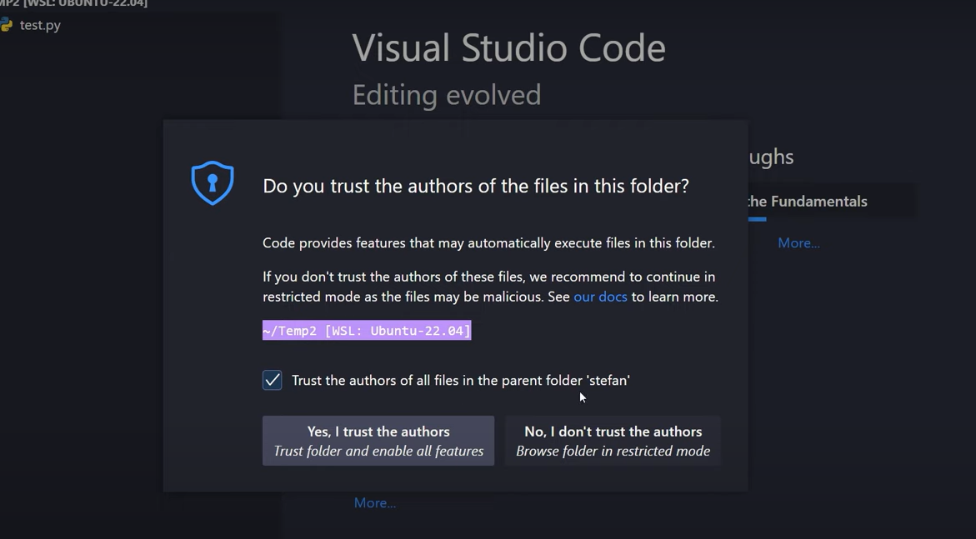

- 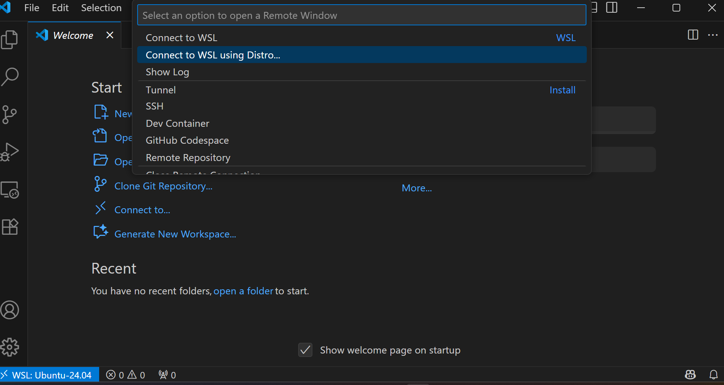
- Install the 'Remote - WSL' extension.
- Open VS Code and connect to your Ubuntu instance via Remote-WSL.
- If propt you to install recommended Python, click on install.
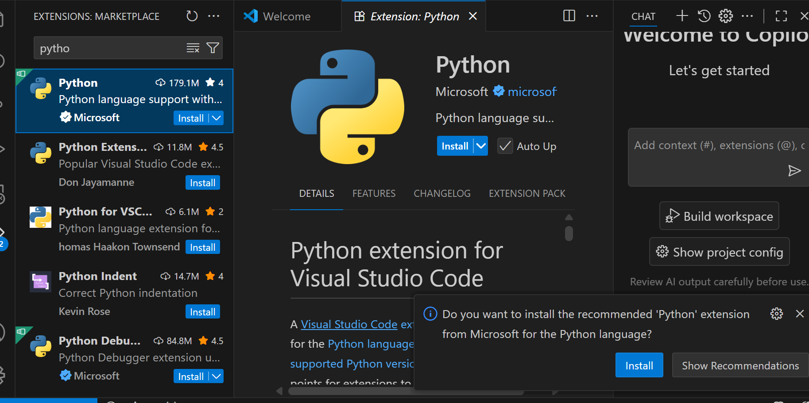

Step 5: Confirm Python Installation
Check the Python version in Ubuntu:
python3 --version
Ubuntu 24.04 comes with Python 3.12 by default.

Deliverables
- Screenshot of 'Virtual Machine Platform' and 'Windows Subsystem for Linux' enabled.
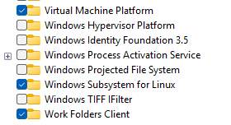

- Screenshot of Ubuntu terminal showing 'lsb_release -a'.
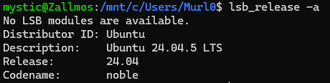

- Screenshot of ROS 2 talker and listener running in separate terminals.
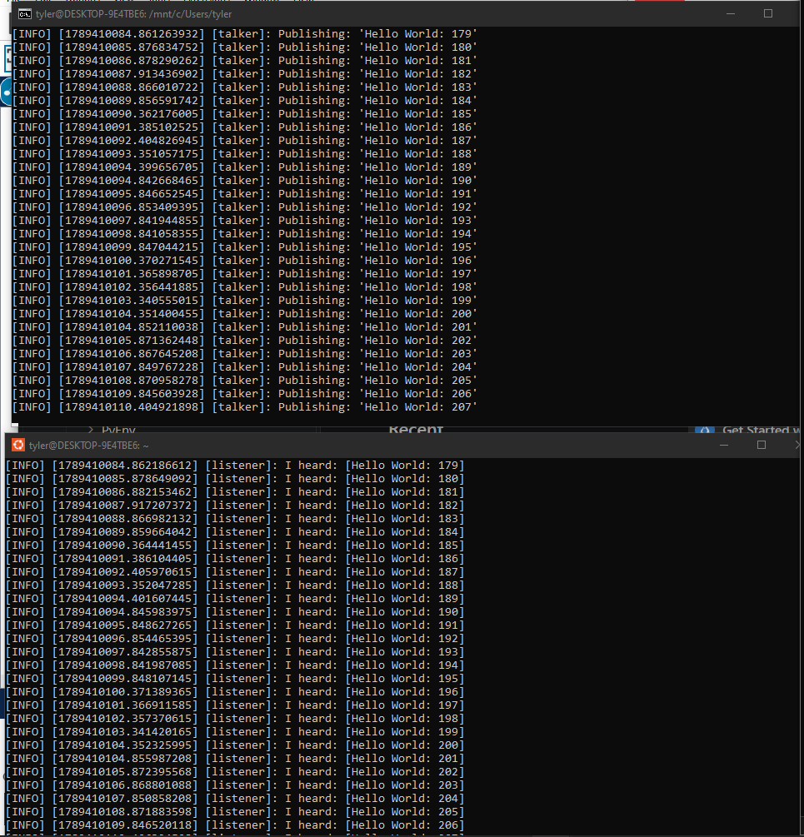

- Short note (2–3 sentences) about any issues or confirmations.

Appendix

In your Windows search bar, type: cmd
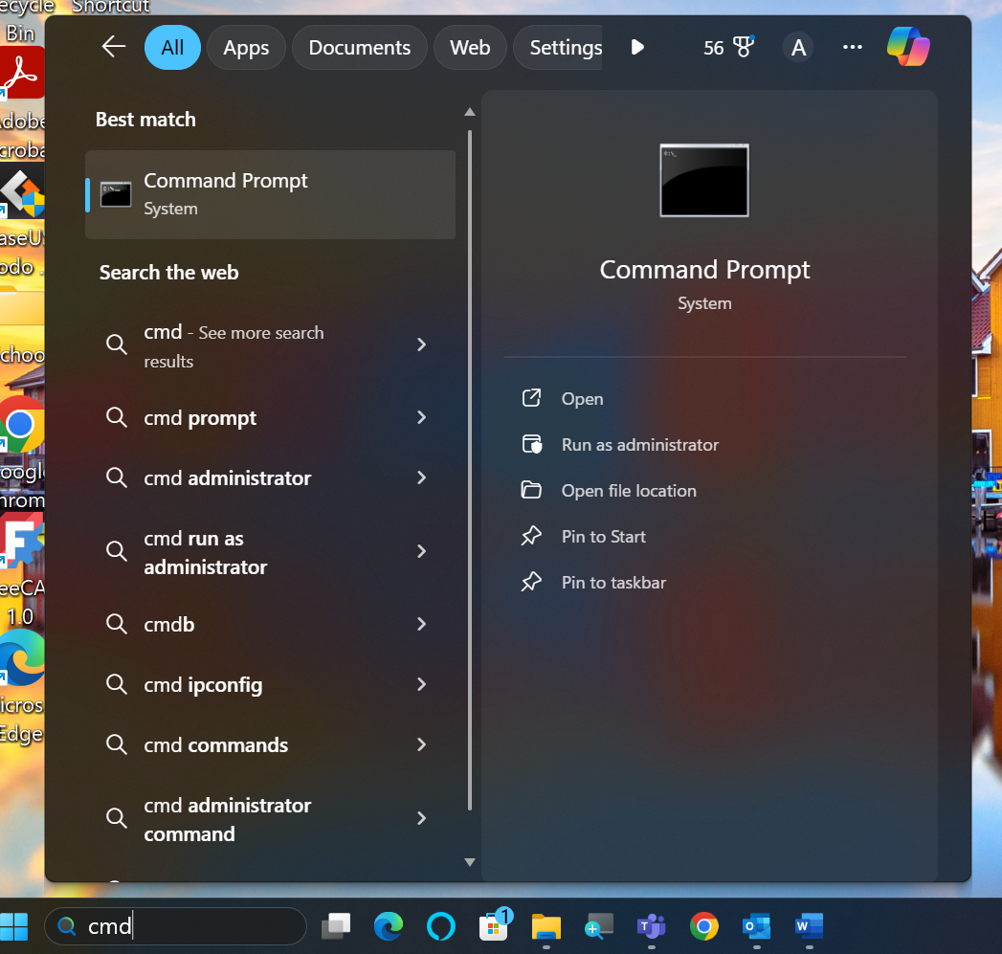
Select: Command Prompt System
From the drop-down arrow, select Ubuntu 24.04 LTS
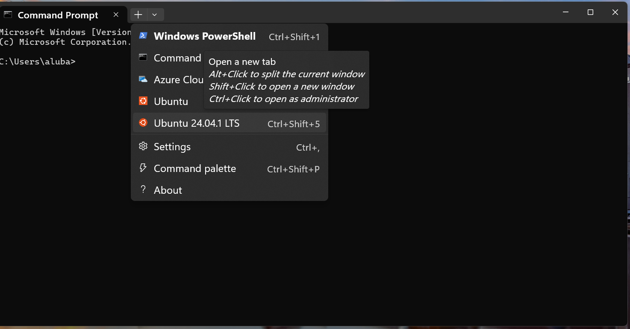
Now you are in Linux Ubuntu!
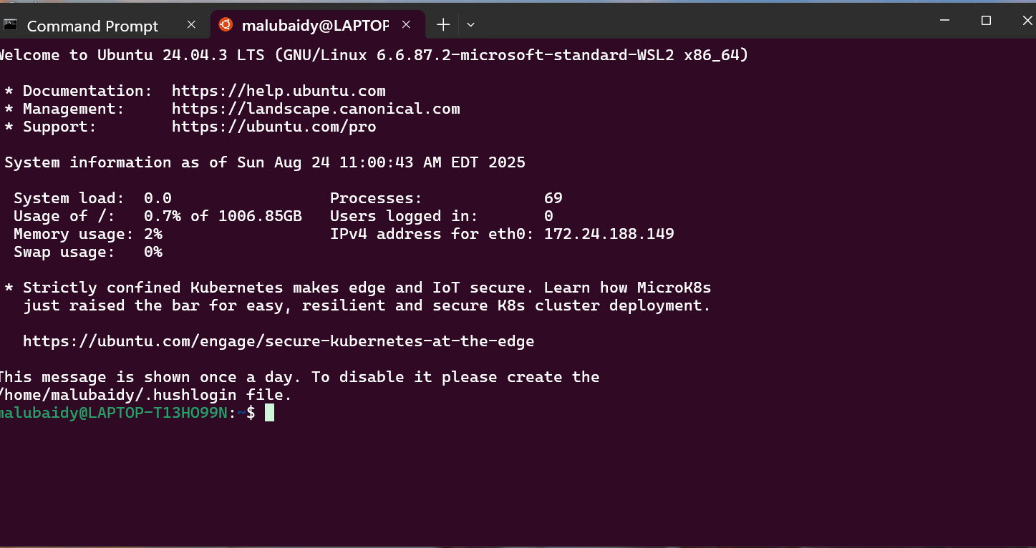

Linux Command Line Practice — Sample Exercises
Objective:
Students will practice using core Linux commands for navigation, file management, viewing content, permissions, and package installation.

1. Navigation and Directories
Open the terminal.
Check your current directory:
pwd
List files in the current directory:
ls
Create a new directory called practice:
mkdir practice
Move into the practice directory:
cd practice
Create two subdirectories named dir1 and dir2:
mkdir dir1 dir2

2. Creating and Managing Files
Inside dir1, create a file called notes.txt:
cd dir1
touch notes.txt
Verify the file exists:
ls
Copy notes.txt to dir2:
cp notes.txt ../dir2/
Move notes.txt from dir1 to the main practice directory:
mv notes.txt ..

3. Viewing and Editing
Inside practice, open notes.txt and add some text using nano (write “Hello Linux” and save with CTRL+O, exit with CTRL+X):
nano notes.txt
Display the contents of notes.txt:
cat notes.txt
Show only the first line of the file:
head -n 1 notes.txt

4. Searching and Filtering
Search for the word 'Linux' in notes.txt:
grep Linux notes.txt
Create a new file with several lines:
echo -e "apple\nbanana\napple\norange" > fruits.txt
Sort the list and remove duplicates:
sort fruits.txt | uniq

5. Permissions and Ownership
View the file permissions for notes.txt:
ls -l notes.txt
Change the file to be readable only by the owner:
chmod 600 notes.txt
Confirm the change:
ls -l notes.txt

6. System and Process Commands
View running processes:
ps
Check disk usage:
df -h
Check the size of the current directory:
du -sh .

7. Package Management (Ubuntu)
Update package lists:
sudo apt update
Install htop:
sudo apt install htop
Run htop and explore the interface (exit with q).

8. Clean Up
Remove the practice directory and its contents:
cd ..
rm -r practice

Where to find all my folders on Ubuntu?
If you would like to navigate to the main folder, open new file explorer on windows (if you are using WSL2) and type:
\\wsl$\Ubuntu-24.04\home\<your-username>
You need to replace <your-username> with you username

